**nExercise #1:**

1. Write the complete SQL statement for creating a new database called **addressbook.**

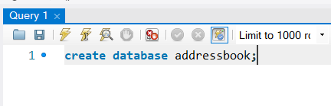

1. Which statement is used to list the information about a table? How do you use this statement?

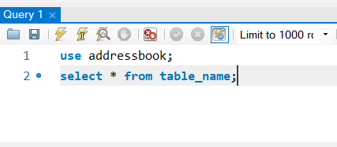

To list the information about a table we use the SELECT statement.  
Others would change how the SELECT statement would list information from the table by changing the ‘*’ with a column name from the table.

1. How would list all the databases available on the system?

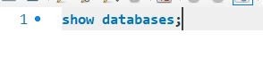

By using the SHOW statement to show all the available databases.

1. Write the statement for inserting the following data in employee data table:

First name: Rudolf

Last name: Reindeer

Title: Business Analyst

Age: 34

Years of Service: 2

Salary: 95000

Perks: 17000

Email: [rudolf@bugnet.com](mailto:rudolf@bugnet.com)

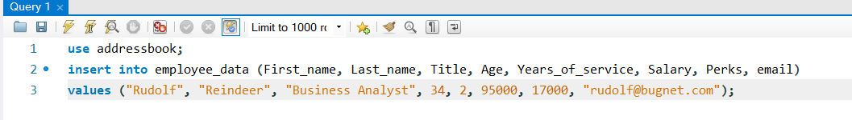

1. Give two forms of the SELECT statement that will list all the data in employee_data table.

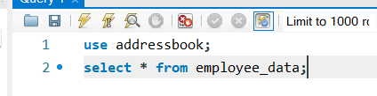

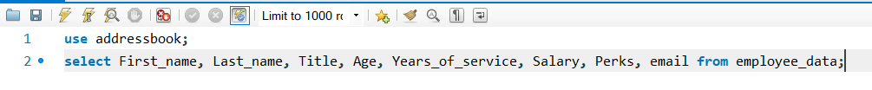

1. What will **select f_name,email from employee_data** display**;**

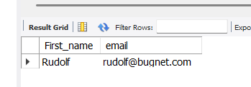

1. Write the statement for listing data from **salary,perks,** and **yos** columns of **employee_data** table.

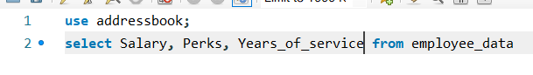

1. How can you find the number of rows in a table using SELECT statement?

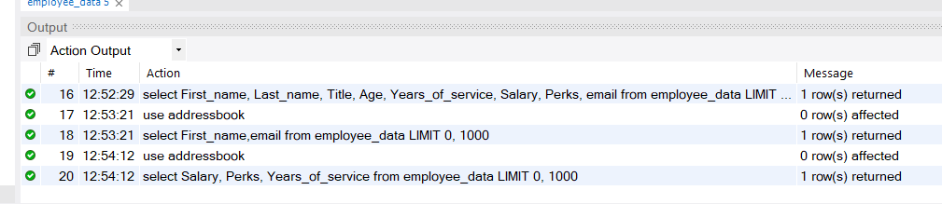

In the Action Output Section in the Message column.

1. What will **select salary, l_name, from employee_data** display?

